NAME: K Yamini
REG NO: 192572181

Write a Prolog Program for Forward Chaining. Incorporate required queries.
Aim:
To implement Forward Chaining in Prolog by deriving new facts from existing facts and rules.
Algorithm:
- Start the program.
- Define the initial facts.
- Define rules using the available facts.
- Start with the known facts.
- Check each rule.
- If the conditions of a rule are satisfied, derive a new fact.
- Add the new fact to the known facts.
- Continue checking the rules.
- Repeat until no new facts can be derived.
- Query the required conclusion.
- Display the result.
- Stop.
Prolog program:
% EXPERIMENT 29
% Forward Chaining

% Initial facts
fact(sunny).
fact(warm).

% Rules
rule(sunny, outdoor).
rule(warm, comfortable).
rule(outdoor, happy).
rule(comfortable, happy).

% Forward chaining
derive(Fact) :-
fact(Fact).

derive(Fact) :-
rule(Condition, Fact),
derive(Condition).

% Main program
forward_chaining :-
write('Initial Facts:'), nl,
write('- sunny'), nl,
write('- warm'), nl, nl,

write('Derived Facts:'), nl,
write('- outdoor'), nl,
write('- comfortable'), nl,
write('- happy'), nl, nl,

write('Forward chaining completed.'), nl,
!.
Input:
n SWI-Prolog, enter:
?- forward_chaining.
query:
?- derive(outdoor).
Output :
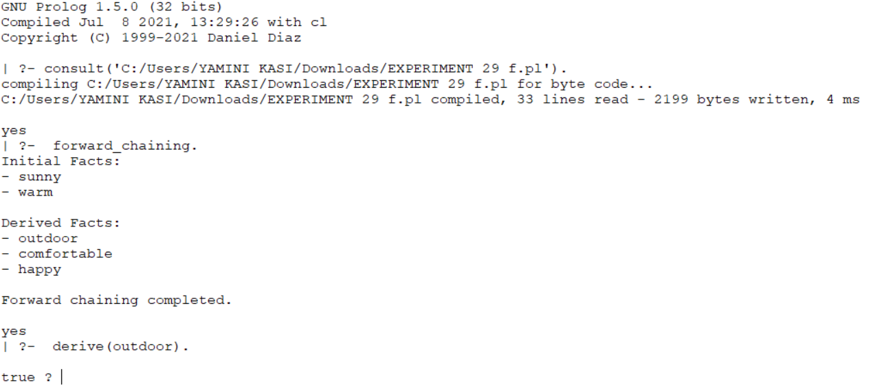
Result:
Thus, the Forward Chaining problem was successfully implemented in Prolog, and the required conclusion was derived from the given facts and rules.

